## Abstract

Institutes evaluate students’ academic performance through a conventional evaluation system which is framed by the institutes under educational policies and/or the institutional rules and regulations. This research study proposes a new fuzzy logic based performance evaluation method. In this method, we consider three parameters attendance, internal marks and external marks which are considered to evaluate students in an IT related undergraduate course. Then an expert system using fuzzy logic is created.

Although performance evaluation using fuzzy logic is complicated and requires additional software, it provides some evaluation advantages. Fuzzy logic evaluation is flexible and provides many evaluation options, while the classical method adheres to constant mathematical calculation. At the application stage, the teacher responsible for the application can edit the ranges of membership functions and rules, permitting non-homogenous but flexible and objective performance evaluation.

## Acknowledgment

Firstly, we would like to thank our teacher and guide Mr Dhaval Bhoi who gave us his valuable suggestions and ideas when we were in need of them. He encouraged us to work on this project. All that we have done is only due to such supervision and assistance and We would not forget to thank them. We also thank all of them who helped us to complete this project. We are immensely grateful to all involved in this project as without their inspiration and valuable suggestion it would not have been possible to develop the project within the prescribed time.

It has given us wide opportunity to think, implement and interact with various aspects of management skills as well as the new emerging technologies. We owe our deep gratitude to our project guide Mr. Dhaval Bhoi, who took a keen interest in our project work and guided us all along our project work by providing all the necessary information for developing a good system.

Last but not least, our parents are also an important inspiration for us. So, with due regards, I express my gratitude to them

Karnav Patel(17CE072)

Mohammadtufel Jerawala (18CE033)

Abstract i

Acknowledgement ii

Chapter 1 Introduction 1

* 1. Purpose 1
  2. Objective 1

Chapter 2 System Information 2

Chapter 3 Methodology and Implementation 3

* 1. Crisp Values(Data) 3
  2. Fuzzification (Fuzzy Input Value) 3
     1. Fuzzification of Input Variable Students 'Attendance 4
     2. Fuzzification of Input Variable Internal Marks 5
     3. Fuzzification of Input Variable External Marks 6
  3. Development of Fuzzy Rule and Inference Mechanism 7
  4. Defuzzification Of Fuzzy Output 7

Chapter 4 LIMITATIONS AND FUTURE ENHANCEMENT 10

* 1. Limitations 11
  2. Future Enhancements  11

Chapter 5 Conclusion 12

**References**

|  |  |  |
| --- | --- | --- |
| **List of Figures** | |  |
| Fig 3.1 Equation…………………………………………………………………….4 | | 4 |
| Fig 3.2 Membership Function of the input variable Students Attendance……………….5 | |  |
| Fig 3.3 Membership Function of the input variable Internal Marks……………………...6 | |  |
| Fig 3.3 Membership Function of the input variable Internal Marks……………………...7 | |  |
| Fig 3.4 FIS System for Input and Output…………………………………………..8 | |  |
| Fig 3.5 Membership Function of the output variable Overall Performance of a student..10 | |  |
|  |
|  |
|  |

## List of Tables

Table 3.1 Input variables of the proposed Evaluation Model 4

Table 3.2 Calculation of Crisp Values of Students’ Attendance 5

Table 3.3 Students’ Attendance in Terms of Linguistic Variables 5

Table 3.4 Calculations of Crisp Values of Internal Marks 6

Table 3.5 Internal Marks in Terms of Linguistic Variables 6

Table 3.6 Calculation of Crisp Values of External Marks 7

Table 3.7 Range for Linguistic Variables of External Marks for Fuzzy input f3 7

Table 3.8 Construction of Fuzzy Inference Rules 8

Table 3.9 Students’ Overall Performance in Terms of Linguistic Variables 8

# INTRODUCTION

## Purpose

Students’ academic success is evaluated by their performance in exams conducted by the institutes or Universities. This system evaluate students academic performance with fuzzy logic based performance evaluation method. In this method, we consider three parameters attendance, internal marks and external marks which are considered to evaluate students final academic performance. The fuzzy inference system has also been used to obtain Performance of Students for different input values student attendance, marks.

## Objective

* To provide a easy evaluation of students’ academic performance.
* This system is very useful for institutes/universities and could help with time taken for evaluation.
* This system is more accurate than conventional methods.

## System Information

For last few years, fuzzy logic theory is being used in the education system. Implementation of the fuzzy logic for various activities of assessment of students’ performance such as evaluation of answer scripts of students in an examination, evaluation of lab examination, projects evaluation and many more. Fuzzy rules have been developed to check how fuzzy rules can be used to model and evaluate the achievement of the learning outcomes in information systems courses. It was proposed to use of the fuzzy set technique to be applied in the evaluation process of the industrial automation systems learning area, which aimed to lessen the evaluation complexity and ambiguity. Neural fuzzy sets containing fuzzy linguistic constructors in rule and query expressions and logical statements were developed, to model the structure of fuzzy linguistic expressions . It has also been investigated whether use of fuzzy logic is suitable for the resolutions of achieving fair assessment. To apply fuzzy logic along with standard numerical grading, a case study was carried out for a poster competition for postgraduates. It was observed that that this fuzzy logic based grading method has many advantages over the traditional method . The outperformance of a Fuzzy Probabilistic Neural Network model to predict personalized student performance was observed in comparison to traditional statistical models as well as traditional back-propagation neural networks . An approach based on fuzzy set was presented to evaluate the results of student-centered learning where there was participation of students to determine the criteria for assessment with their weightage . It was also found in another study that the evaluation with Fuzzy Logic renders great flexibility and robustness in the evaluation process. This system has the capabilities to handle imprecise and missing data .The fuzzy inference system has also been used to obtain Performance of Students for different input values of Teaching Effectiveness, Student Attendance, and other Facilities .

**3. Implementation**

**3.1 Crisp Value (Data)**

The values for input variables may be collected from the records of the students’ end term result with internal assessment (f1), external Assessment (f2) and overall attendance of the Semester (f3) shown in Table I

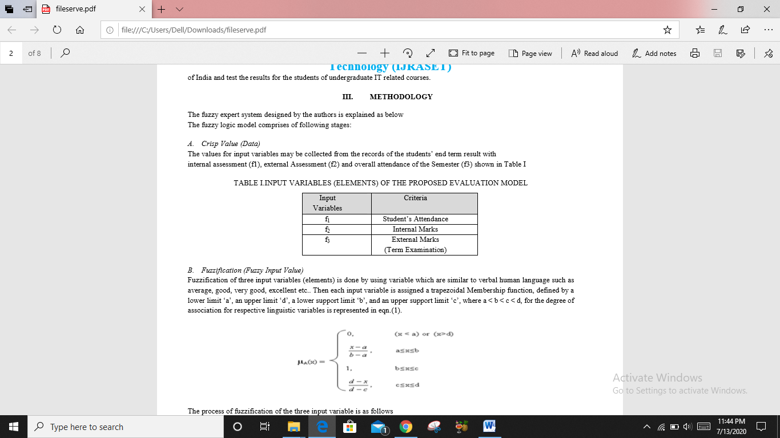

**3.2 Fuzzification (Fuzzy Input Value)**

Fuzzification of three input variables (elements) is done by using variable which are similar to verbal human language such as average, good, very good, excellent etc.Then each input variable is assigned a trapezoidal Membership function, defined by a lower limit ‘a’, an upper limit ‘d’, a lower support limit ‘b’, and an upper support limit ‘c’, where a < b < c < d, for the degree of association for respective linguistic variables is represented in eqn.(1).

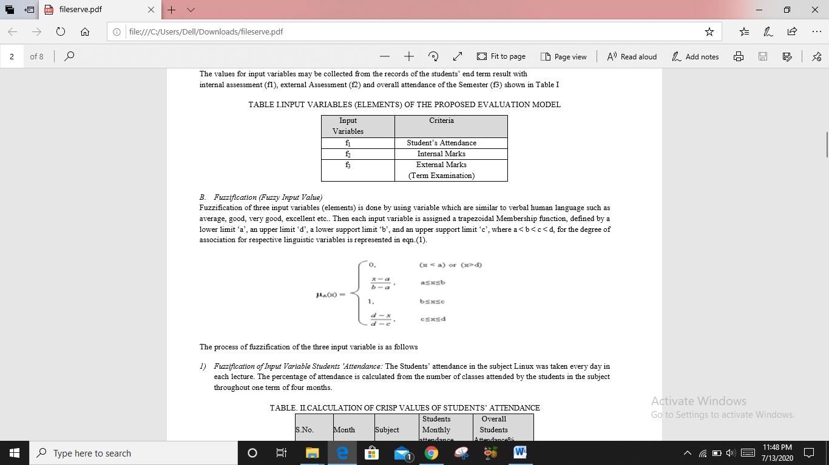

Figure 3.1

The process of fuzzification of the three input variable is as follows

**3.2.1 Fuzzification of Input Variable Students 'Attendance**:

The Students’ attendance in the subject was taken every day in each lecture. The percentage of attendance is calculated from the number of classes attended by the students in the subject throughout one term of four months.

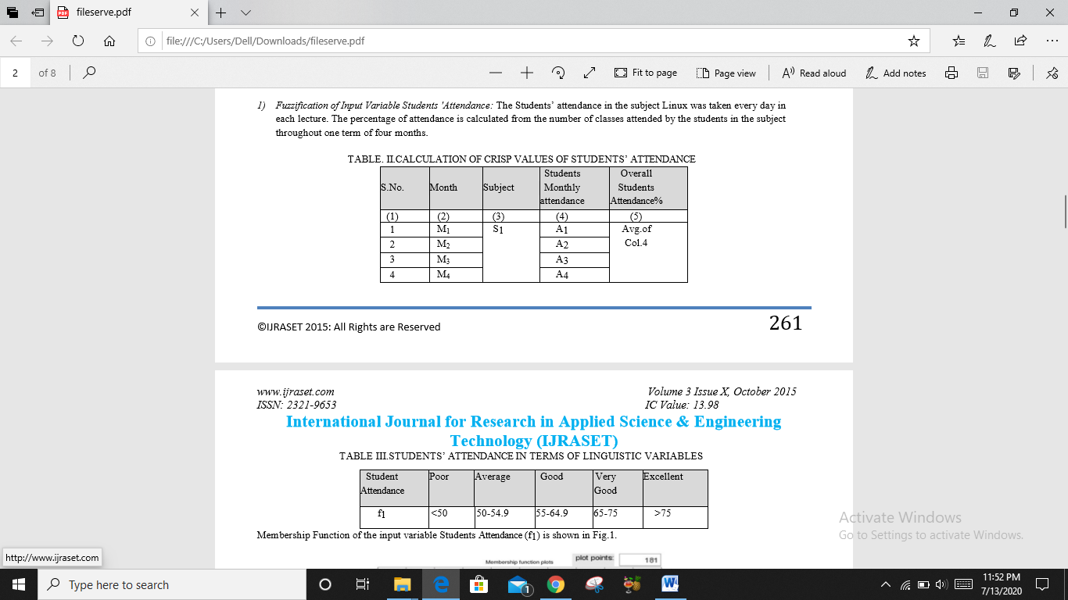

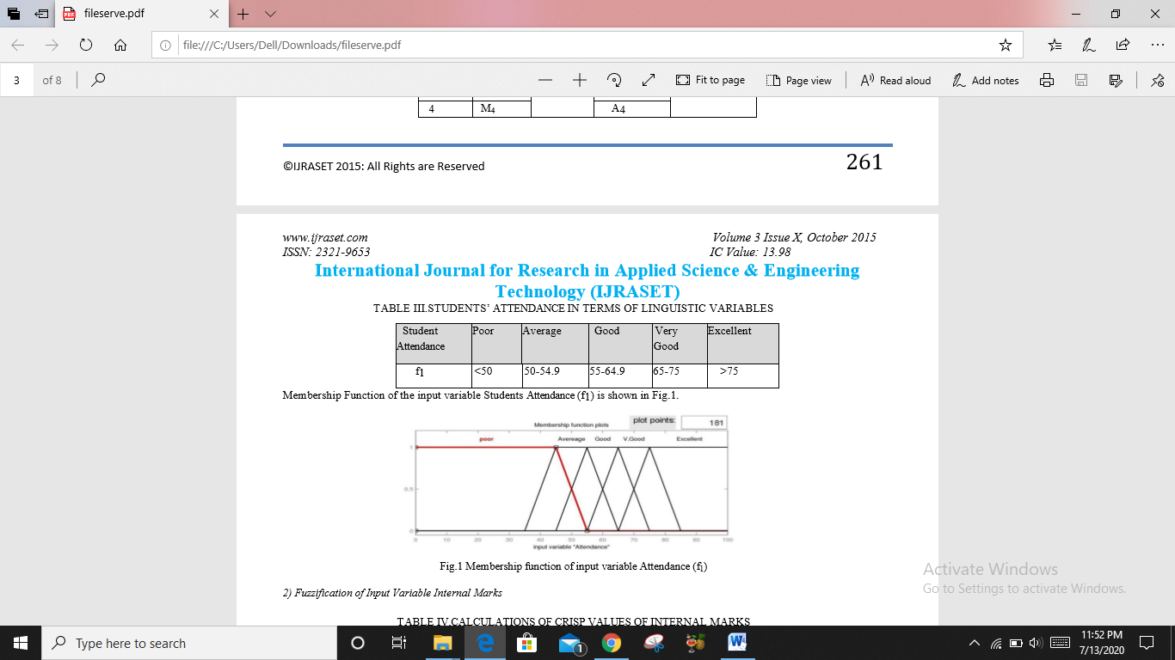

Membership Function of the input variable Students Attendance (f1) is shown in Fig.1.

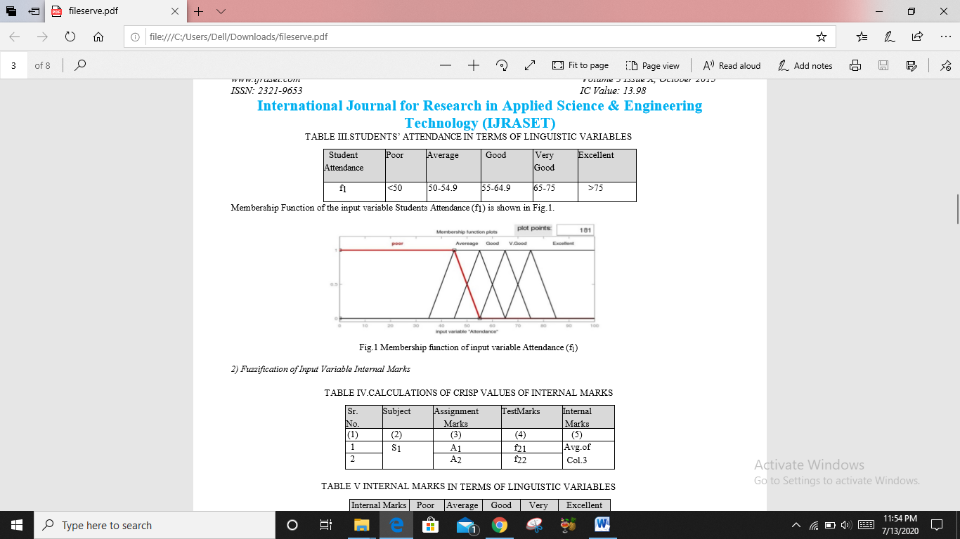

Figure 3.2

**3.2.2** **Fuzzification of Input Variable Internal Marks:-**

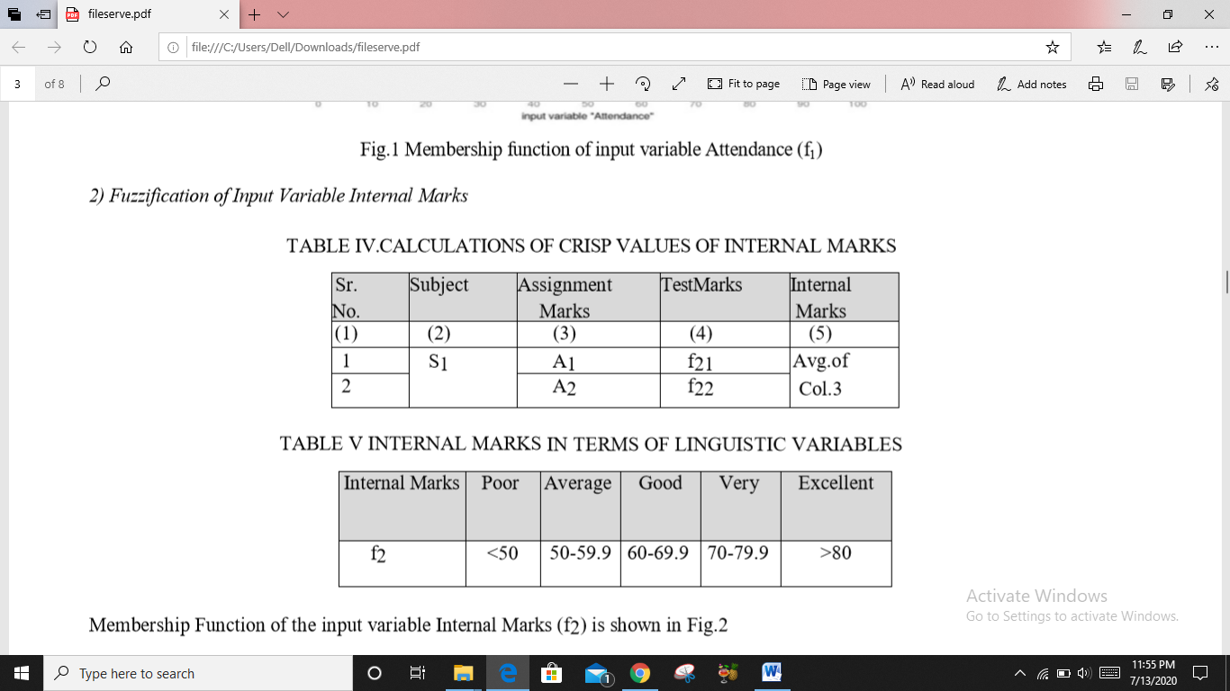

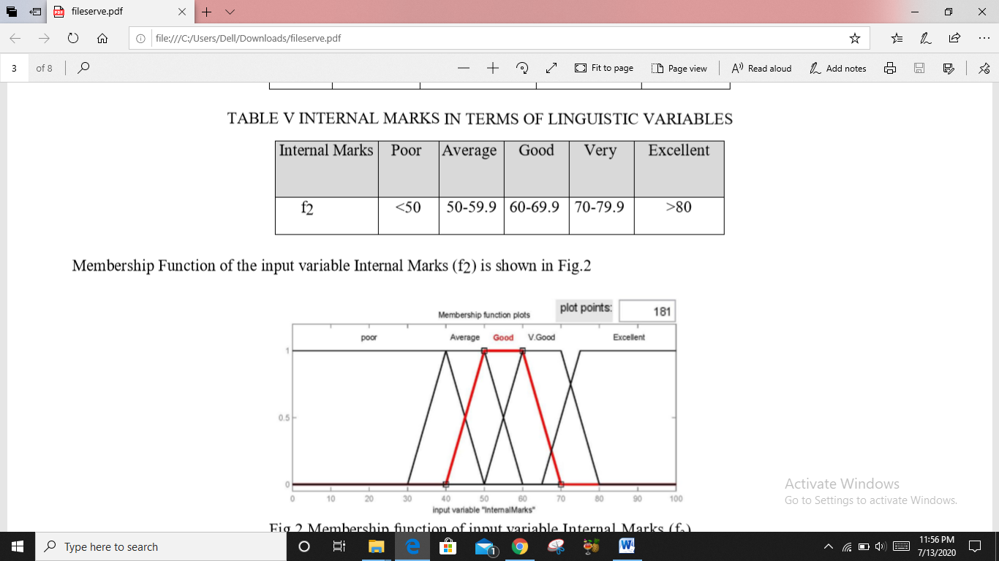

Membership Function of the input variable Internal Marks (f2) is shown in Fig.2

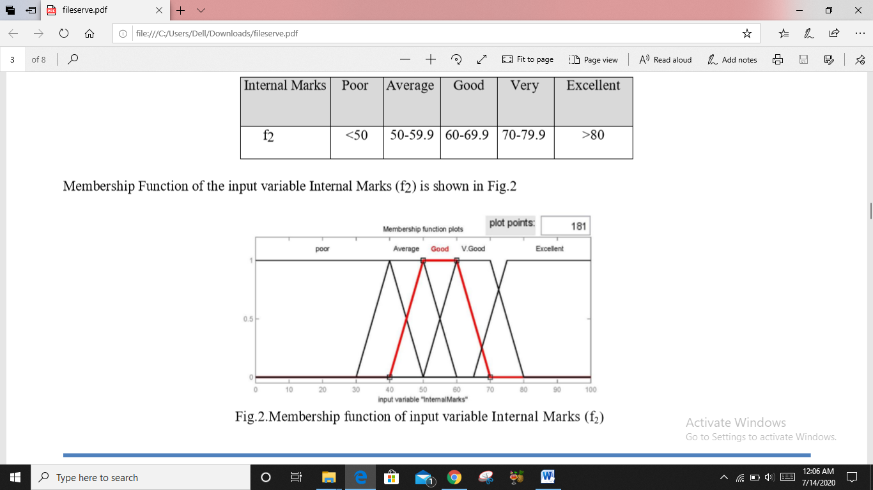

Figure 3.3

**3.2.3 Fuzzification of Input Variable External Marks:-**

After the end of the term, final exam is conducted for all subjects.

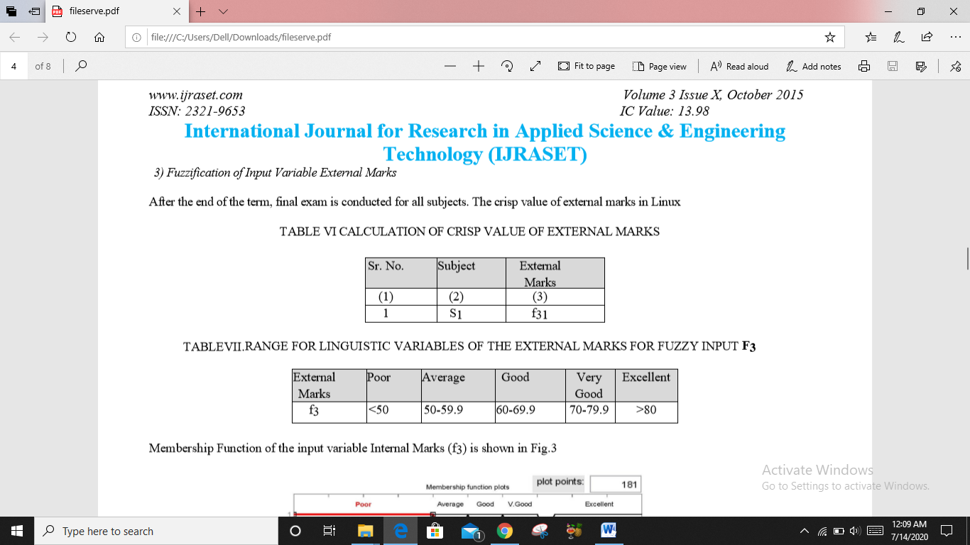

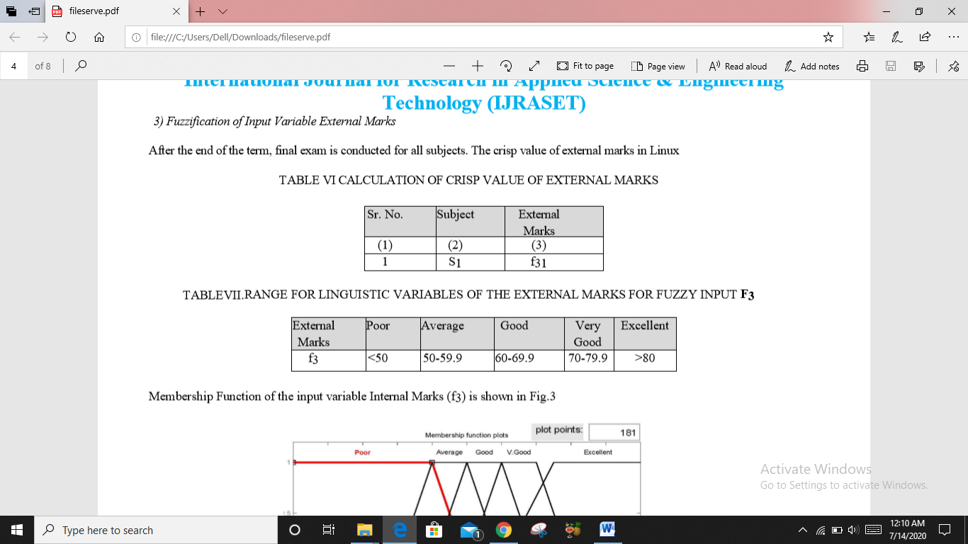

Membership Function of the input variable Internal Marks (f3) is shown in Fig.3

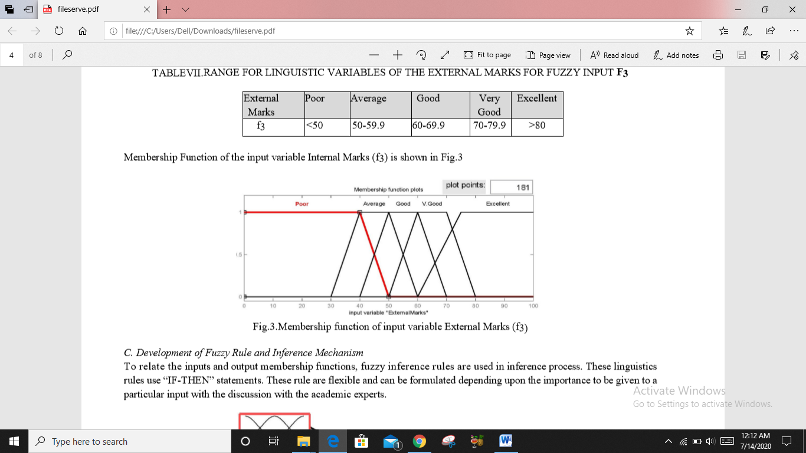

Figure 3.3

**3.3 Development of Fuzzy Rule and Inference Mechanism:-**

To relate the inputs and output membership functions, fuzzy inference rules are used in inference process. These linguistics rules use “IF-THEN” statements. These rule are flexible and can be formulated depending upon the importance to be given to a particular input with the discussion with the academic experts.

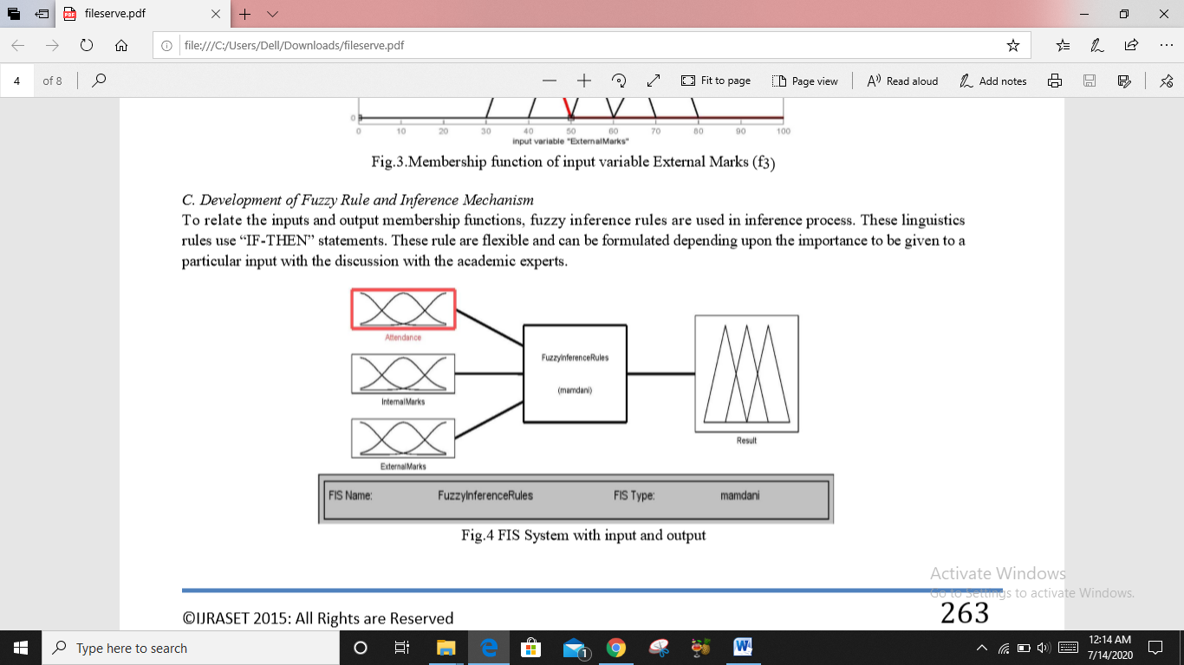

Figure 3.4

**3.4 Defuzzification Of Fuzzy Output (To Find Out The Final Result With The Help Of Suitable Defuzzification Method)**

The output variable F is the students’ final performance. If the three input variables are expressed as f1, f2, f3 and membership functions of the three input variables are µ(f1), µ(f2), µ(f3.) respectively for rule k=1,2,3,4,........r, then The membership function of the output variable F is given by equation (2).

µF(x)=Maxk [min[µ(f1),µ(f2),µ(f3)]], k=1,2,3,4,.....r(2)

This expression expresses the value of membership function for output variable overall performance for active rules for each input. The logical operator AND is used among the three inputs. Similar to the fuzzy linguistic variables of input we have used the linguistic variables for output which have been shown in Table IX

Table VIII represents the rules for the three inputs and corresponding output

TABLE IX. STUDENTS’ OVERALL PERFORMANCE IN TERMS OF LINGUISTIC VARIABLE

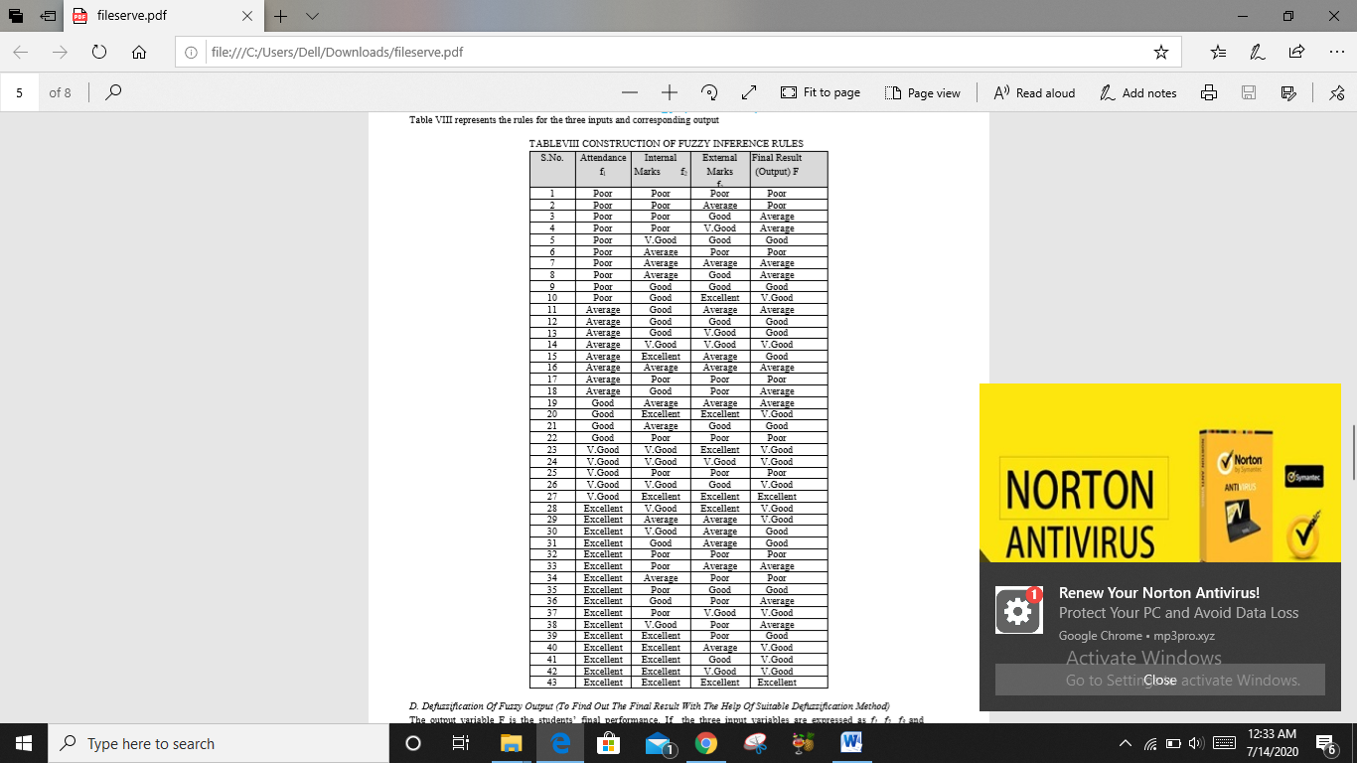

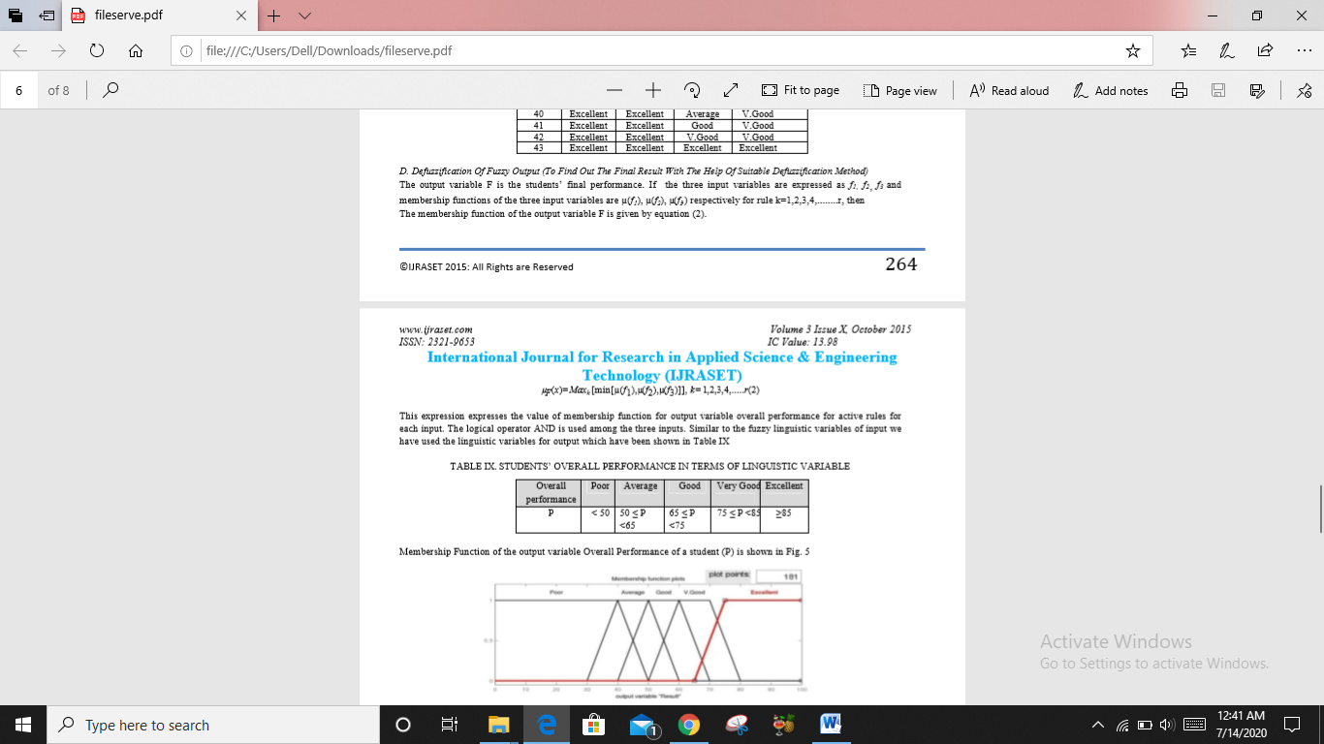

Membership Function of the output variable Overall Performance of a student (P) is shown in Fig. 5

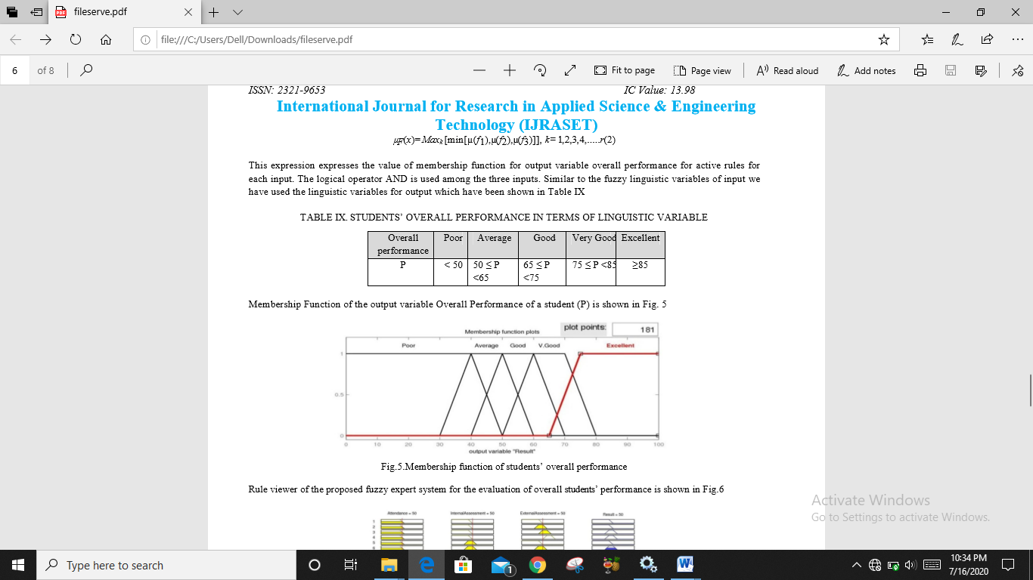

Figure 3.5

**4. LIMITATIONS AND FUTURE ENHANCEMENT**

**4.1 Limitations**

**Fuzzy logic** is not always accurate, so The results are perceived based on assumption, so it may not be widely accepted.

**Fuzzy** systems don't have the capability of machine learning as-well-as neural network type pattern recognition.

This System only give about Students Academic criteria Average like Internal Marks,

External Marks and Attendance.

By using of Matlab this system is Easy to implement but using Code this is difficult.

**4.2 Future Enhancements**

For the future we are upgrading this system For another criteria Like Employee Performance And we can Also make an Application which Give a output of Any Students criteria Which is exist in database And this system is also applicable for university performance

**5. CONCLUSION**

The t-test is conducted using MS Excel. As per value of t test we cannot reject the null hypothesis that two results are similar as p-value of test statistics is 0.927( < 0.975) and the t-statistic is -0.09, which does not fall into the rejection region. In other words, we accept the null hypotheses that means conventional result is equal to the mean fuzzy system result with 95% confidence level. This shows that that the expert system can provide the same results as conventional method. Therefore one can apply computer based Fuzzy System Approach in plane of time consuming conventional method. However, in some cases, the variations in results from fuzzy system have been observed for some students who have same result through conventional method. It was due the difference in their attendance which shows that expert system incorporates input attendance effectively. On the contrary in the conventional system, for a regular course, a student must have mandatory attendance failing to which the student may not be allowed to appear in exams. This shows that the expert system provides flexibility to the inflexible conventional system which is greatly required in present age of technology**.**

**REFERENCES**

* **IEEE Link:**
* http://ieeexplore.ieee.org/document/7488610/
* <http://www.ijraset.com/fileserve.php?FID=3368>
* <https://ieeexplore.ieee.org/abstract/document/6828010>
* <https://ieeexplore.ieee.org/abstract/document/6675615>
* <https://www.ijraset.com/fileserve.php?FID=3368>